Topic: Measurement EQ: How do I find the area of different shapes? (practice)
This is a check for understanding
1. | 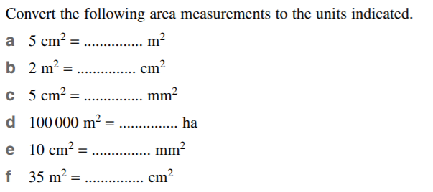
2. | 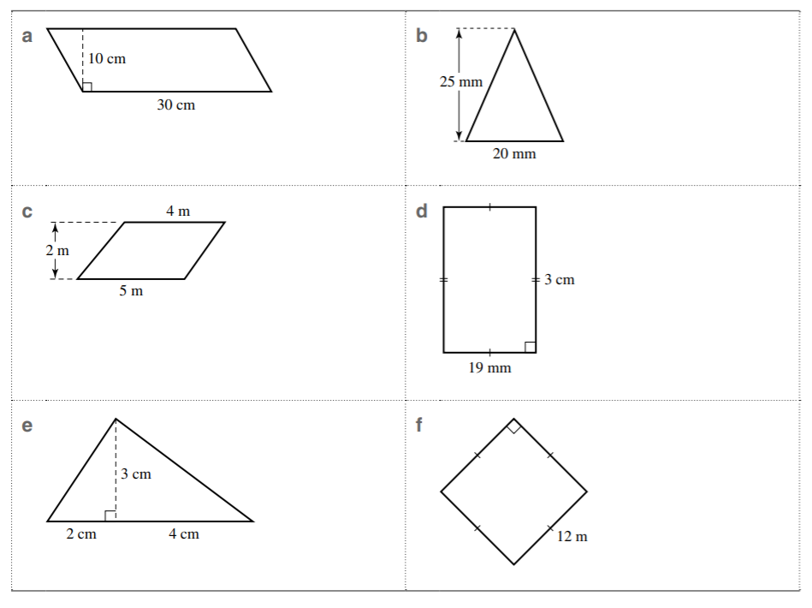
3. | Find the area of the triangle used to rack up the billiard balls below.  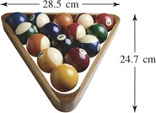
4. | Georgia is planning to create a feature wall in her lounge room by painting it a different colour. The wall is 4.6 m wide and 3.4 m high.  - Calculate the area of the wall to be painted.  - Georgia knows that a 4 litre can of paint is sufficient to cover 12 square metres of wall. How many cans must she purchase if she needs to apply two coats of paint?

